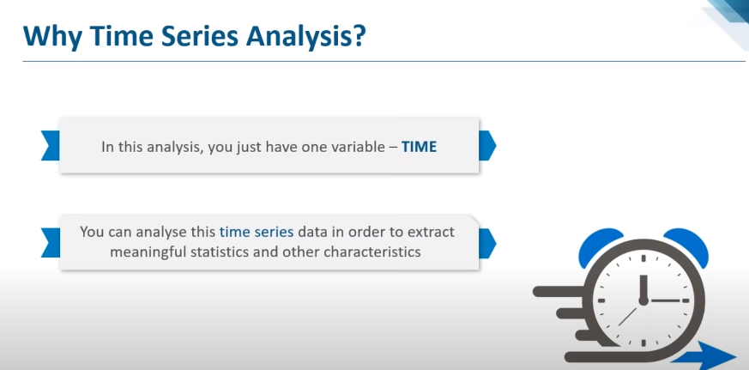

A time series is nothing but a sequence of various data points that occurred in a successive order for a given period of time

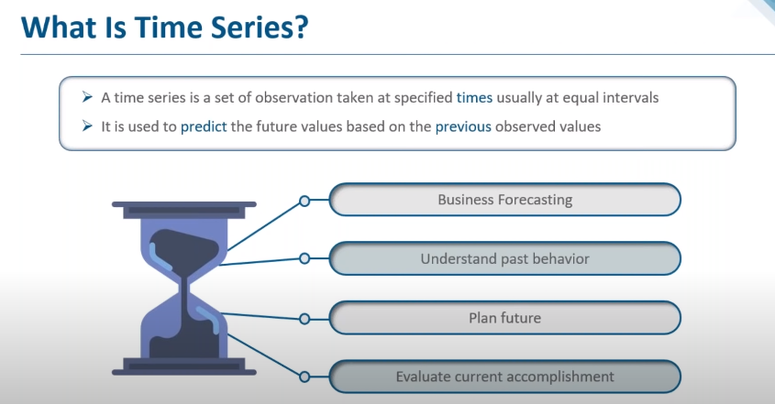

TSA is the backbone for prediction and forecasting analysis, specific to the time-based problem statements.

- Analyzing the historical dataset and its patterns
- Understanding and matching the current situation with patterns derived from the previous stage.
- Understanding the factor or factors influencing certain variable(s) in different periods.
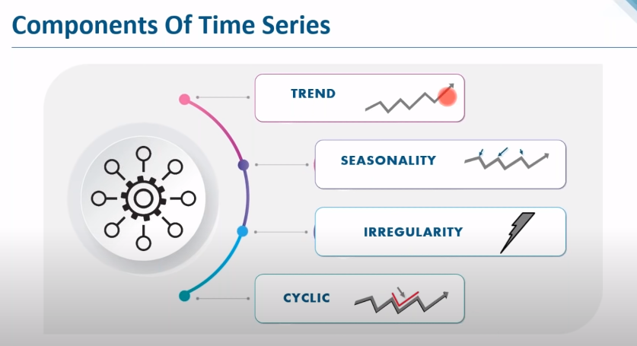

Time series has the below-mentioned limitations, we have to take care of those during our analysis,

- Similar to other models, the missing values are not supported by TSA
- The data points must be linear in their relationship.
- Data transformations are mandatory, so a little expensive.
- Models mostly work on Uni variatdata.

Data Types of Time Series
Let’s discuss the time series’ data types and their influence. While discussing TS data-types, there are two major types.
- Stationary
- Non- Stationary
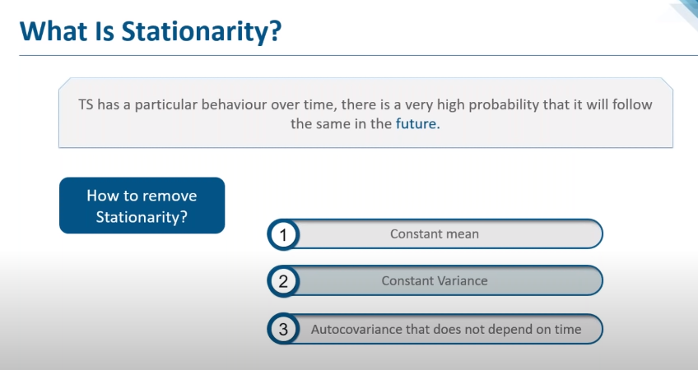

Stationary: A dataset should follow the below thumb rules,
- The MEAN value of them should be completely constant in the data during the analysis
- The VARIANCE should be constant with respect to the time-frame
- The COVARIANCE measures the relationship between two variables.
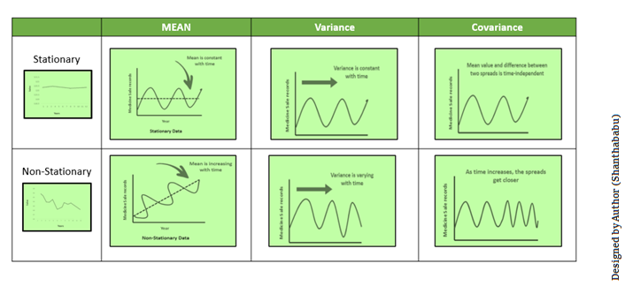
Moving Average Methodology
The commonly used time series method is Moving Average. This method is slick with random short-term variations. Relatively associated with the components of time series.

This method removes the underlying trend in the time series also known as Detrending

The Moving Average (MA) (Or) Rolling Mean: In which MA has calculated by taking averaging data of the time-series, within k periods.

Let’s see the types of moving averages:
- Simple Moving Average (SMA),
- Exponential Moving Average (EMA)

Simple Moving Average (SMA)
The SMA is the unweighted mean of the previous M or N points. The selection of sliding window data points, depending on the amount of smoothing is preferred since increasing the value of M or N, improves the smoothing at the expense of accuracy.

Exponential Moving Average (EMA)
#Suitable for time series data without trend or seasonal components
EMA is mainly used to identify trends and to filter out noise. The weight of elements is decreased gradually over time. This means It gives weight to recent data points, not historical ones.

Compared with SMA, the EMA is faster to change and more sensitive.
α –>Smoothing Factor.
It has a value between 0,1.
Represents the weighting applied to the very recent period.
When α = 0, the forecasts are equal to the average of the historical data. When α = 1, the forecasts will be equal to the value of the last observation.

An exponential model would be appropriate for situations where the increase or decrease starts slowly but then accelerates rapidly.

Check for Stationarity

Two common methods to check for stationarity are Visualization and the Augmented Dickey-Fuller (ADF) Test.


Converting Non- stationary into stationary
Let’s discuss quickly how to convert Non- stationary into stationary for effective time series modeling. There are two major methods available for this conversion.
- Detrending
- Differencing

Holt’s Linear Trend Method

#Suitable for time series data with a trend component but without a seasonal component

Expanding the SES method, the Holt method helps you forecast time series data that has a trend. In addition to the level smoothing parameter α introduced with the SES method, the Holt method adds the trend smoothing parameter β*. Like with parameter α, the range of β* is also between 0 and 1.

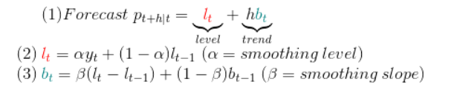

Holt-Winters’ Seasonal Method

#Suitable for time series data with trend and/or seasonal components

The Holt-Winters model extends Holt to allow the forecasting of time series data that has both trend and seasonality, and this method includes this seasonality smoothing parameter: γ.

Basically, there are 2 models multiplicative and additive. The additive model is based on the principle that the forecasted value for each data point is the sum of the baseline values, its trend, and the seasonality components.
Similarly, the multiplicative model calculates the forecasted value for each data point as the product of the baseline values, its trend, and the seasonality components.

Limitations of Holt-Winter’s Technique does not perform well with lower amount of data.

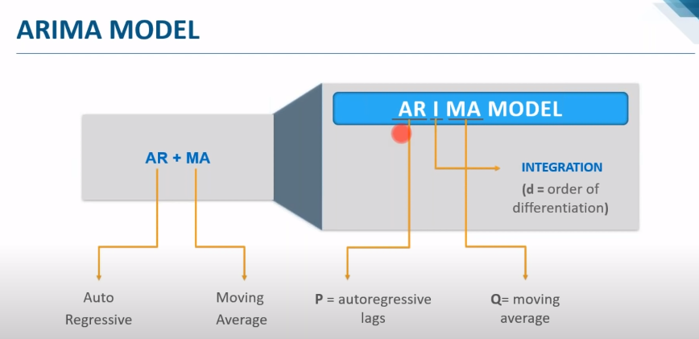

https://www.bounteous.com/insights/2020/09/15/forecasting-time-series-model-using-python-part-one/

